Class #7

Drawing

Gavin Spielman

Metropolitan Museum of Art visit to the Impressionist Wing

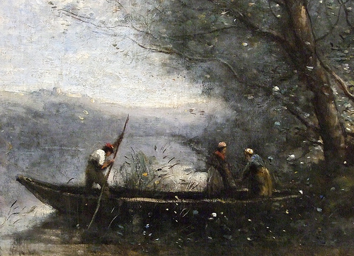

We will be going to the museum today to look at some of the artists I have been discussing in class. We will be sketching the paintings in our sketchbooks, in pencil – as well as taking photos, and buying postcards at the shop.

Seeing color as tone.

Three drawings of master paintings are expected, including the frame, description and date, as well as the name of the artist.

The third painting can depict elements of perspective, as to create a space for the painting (sketch) to live inside. Think composition when drawing the paintings in your book. Setting aside the WARM and COOL values we see, try to discern from what value is related to what other value throughout the painting(s) you choose.

Find a few postcards to buy in the shop, we will be using this in class.